Dis- **Peru-Chavin- Jaguar with Crenelated crown**

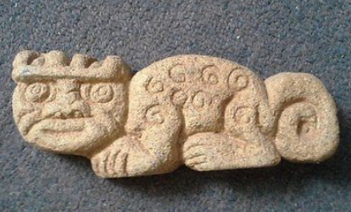

**Formal Label: Peru-Chavin- Jaguar with Crenelated crown**

**Accession Number:**

**LC Classification:** F3429.1.C48

**Date or Time Horizon:** **900 BCE–250 BCE**

**Geographical Area:** coastal Peru from Chan Chan to Pachacamac

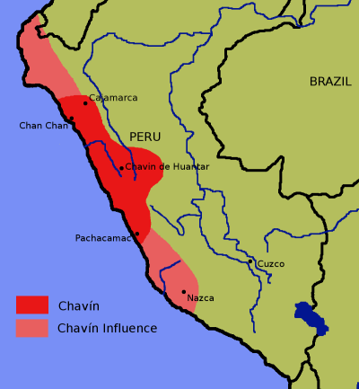

**Map**: Chavin culture extent. Created by [en:User:Zenyu](https://en.wikipedia.org/wiki/User:Zenyu) and released to {{PD}} by Zenyu, source.

The Chavín developed their culture in the Mosna Valley at the confluence of the Mosna and Huachecsa near Chavin de Huantar at 3,150 metres (10,330 ft) above sea level which encompasses three ecozones: the *quechua (*montane valleys), the *suni* (scrubs and agriculture), and the *puna* (mountaintop grassland) (Burger 2008; Pulgar 1979).

**Cultural Affiliation:** Chavin

**Medium:** Granite

**Dimensions: L 6 in  
Weight:**

**Provenance:**

**Condition:** Museum quality

**Discussion:**

The jaguar had a particular significance in many pre-Columbian cultures and most especially in the Chavin culture. This society initially in the *Urabarriu* period (900-500 BCE) depended on hunting and gathering as well as some maize agriculture. A jaguar cult developed that revered the powers of the feline, but mostly for hunting. However, in one century (500-400 BCE) the society coalesced in the *Chakinani* period from dispersed settlements at Chavin de Huantar into gathered settlements in the ceremonial vicinity. During this period deer hunting was diminished as the domestication of llamas was developed. Trade with outside communities also expanded. The jaguar cult became less associated with hunting and more associated with war.

Then, in the *Jarabarriu* Period, the final stage of the Chavín culture (400-250 BCE), a dramatic increase in population occurred at a time with vastly increased agriculture and an ameliorated climate. It is during this period that the jaguar cult expanded with increasing power being taken by élites who developed a version of shamanism around the perceived qualities of the jaguar spirit. It is still uncertain whether the psychotropic San Pedro cactus was used in the cult at this time. This reverence for the jaguar was an idealization that became a means of acquiring power and of stratifying the society. Those who were accepted into the jaguar cult represented the embodiment of extreme skill with an emphasis on war, defending the preservation and the expansion of territory. As the jaguar was seen as the perfect animal, in complete symbiosis with nature, and was able to capture virtually any other prey, the ideal warrior was seen to merge with the soul of the jaguar and to become one with him and set an example to the community. In the world-view of the Chavin of the *Jarabarriu* Period, the warrior was shamanically merged with the jaguar spirit, having assimilated its skill, strength, cunning, serenity, determination and precision.

This plaque of this revered jaguar spirit is evidence of the last stage of the Chavin culture. During this period the development of asymmetrical power by the jaguar cult élites is reflected in the extensive remodeling of the Chavin d Huantar temple (Kembel and Rick 2004). Perhaps this granite jaguar was emplaced in one of these renovations as a symbol of the emerging rulers.

**References:**

Burger, Richard L. 2008. "Chavin de Huantar and its Sphere of Influence", In *Handbook of South American Archeology*, edited by H. Silverman and W. Isbell. New York: Springer, pp. 681–706.

Burger, Richard L., and Nikolaas J. Van Der Merwe (1990). "Maize and the Origin of Highland Chavín Civilization: An Isotopic Perspective", *American Anthropologist* 92(1):85–95.

Pulgar Vidal, Javier. 1979. *Geografía del Perú; Las Ocho Regiones Naturales del Perú.* Edit. Universo S.A., Lima 1979.

Kembel, Silvia Rodriquez and John W. Rick. 2004. "Building Authority at Chavin de Huantar: Models of Social Organization and Development in the Initial Period and Early Horizon", in *Andean Archaeology*, Malden, Massachusetts: Blackwell Publishers.